Binary Indexed Tree (Fenwick Tree)
with working, steps, intuition, complexity, and visualization

🔷 1. BINARY INDEXED TREE (Fenwick Tree)
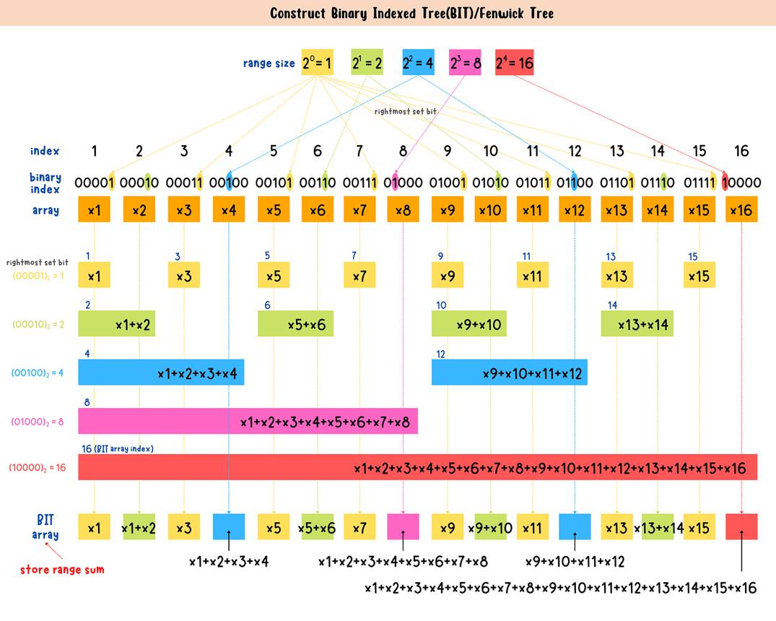
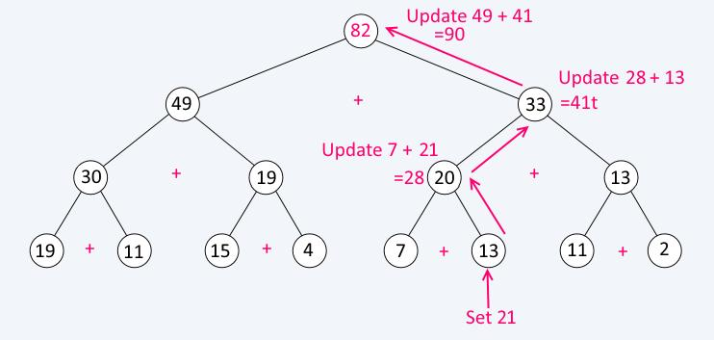
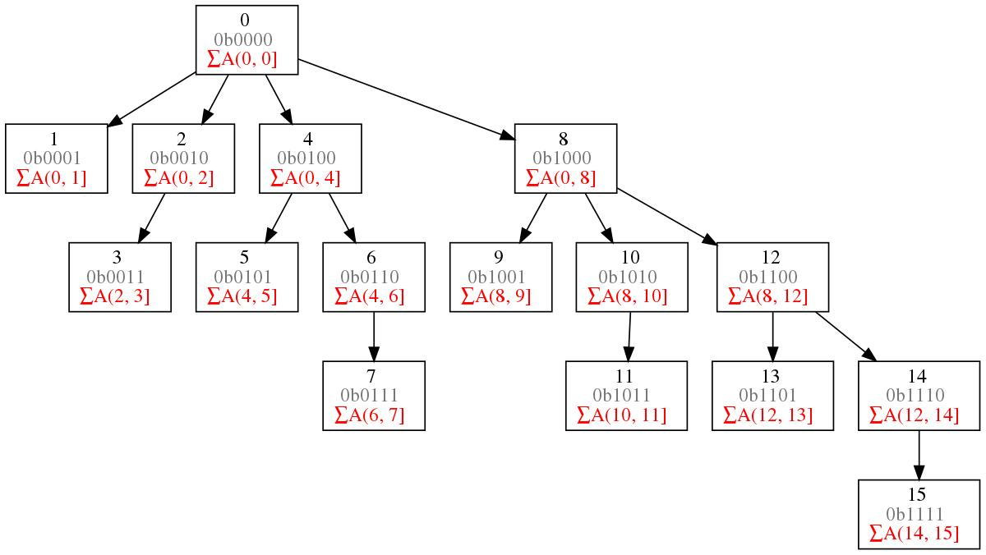
6

✅ Definition
Binary Indexed Tree is a data structure used to perform:
✔ Prefix sum queries
✔ Updates efficiently
👉 Both in O(log n) time

📘 Core Idea
👉 Use binary representation + last set bit
- Each index stores sum of range
- Move using:
  - index - (index & -index) → parent
  - index + (index & -index) → next

⚙️ OPERATIONS

🔹 1. getSum(index)
📌 Steps
- index = index + 1
- sum = 0
- While index > 0:
  - sum += BIT[index]
  - index = index - (index & -index)
- Return sum

🔹 2. update(index, val)
📌 Steps
- index = index + 1
- While index ≤ n:
  - BIT[index] += val
  - index = index + (index & -index)

🔹 Range Sum
sum(l, r) = getSum(r) - getSum(l-1)

⏱ Complexity
Operation | Time
Update | O(log n)
Query | O(log n)
Space | O(n)

🎯 Use Cases
- Range sum queries
- Inversion count
- Frequency queries

🧠 Memory Trick
👉 BIT = Prefix + Binary jumps

🔷 2. SQUARE ROOT DECOMPOSITION
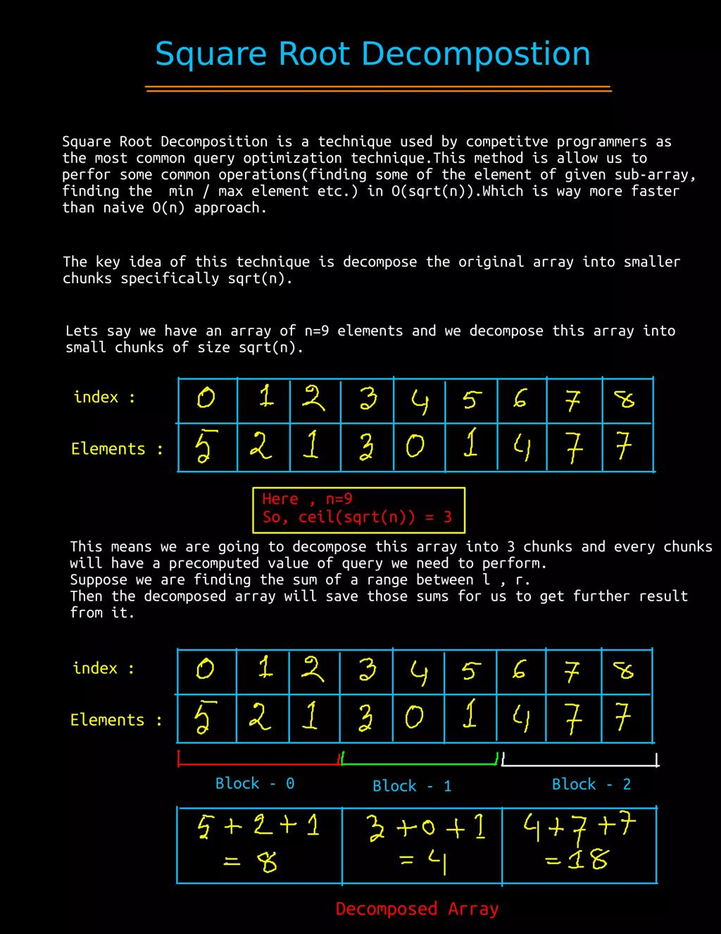
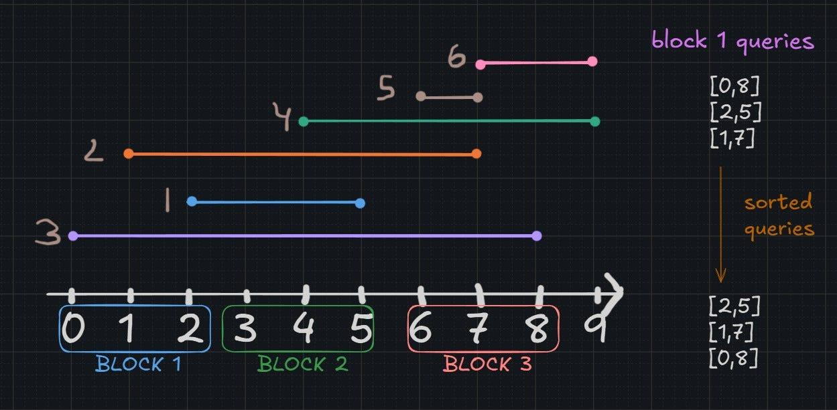

✅ Definition
Divide array into √n blocks to optimize queries

📘 Core Idea
👉 Jump blocks instead of elements
- Block size = √n
- Precompute block sums

⚙️ WORKING

🔹 Preprocessing
📌 Steps
- Divide array into √n blocks
- Store sum of each block

🔹 Query(l, r)
📌 Steps
- Traverse elements till block boundary
- Add full blocks directly
- Traverse remaining elements

🔹 Update(index, val)
📌 Steps
- Find block number
- Update block sum
- Update array value

⏱ Complexity
Operation | Time
Query | O(√n)
Update | O(1)
Space | O(n)

🎯 Use Cases
- Range sum queries
- Frequent queries + updates

🔄 BIT vs SQRT DECOMPOSITION
Feature | BIT | SQRT
Query | O(log n) | O(√n)
Update | O(log n) | O(1)
Complexity | Better | Simpler
Use | Advanced | Easy CP

🧠 FINAL MEMORY SUMMARY
- BIT → binary jumps → fast (log n)
- SQRT → block jumps → simple

🧾 FINAL 5-LINE EXAM ANSWER
- BIT supports prefix queries in O(log n)
- Uses binary operations for traversal
- SQRT divides array into √n blocks
- Queries answered in O(√n)
- Both used for range query optimization

